Installing GAP CLoSR Tools

Introduction
GAP_CLoSR_Tools is graphical user interface (GUI) software that has been developed to facilitate the use of the GAP CLoSR tools and methods previously developed by Alex Lechner as part of the Australian Government’s National Environmental Research Programme (NERP) Landscapes and Policy hub. GAP_CLoSR_Tools was developed by Michael Lacey, also as part of the NERP Landscapes and Policy hub. This GUI application is designed to integrate with tools used in the GAP CLoSR process. The purpose is to provide an easy to use means of generating input datasets for later processing using Graphab and Circuitscape which are other software used in the GAP CLoSR process.

Geoprocessing is accomplished using the geoprocessing tools of ESRI ArcGIS (version 10.0 or above). At the core of the GUI application is a set of Python script versions of the GAP CLoSR tools. The GUI has been designed so that users do not need to know about scripting or how to use Python. All of that is designed to run in the background. Once the application has been set up, the user just needs to enter the required variables and run the scripts using the GUI controls following the GAP CLoSR methods. Some additional GIS processing in ArcGIS may be required as outlined in GAP CLoSR documentation (eg. tutorial). Advanced users who are familiar with Python scripting and ESRI geoprocessing tools will have the option of modifying the scripts and a range of script-related settings. A user manual is being written and will be available soon.

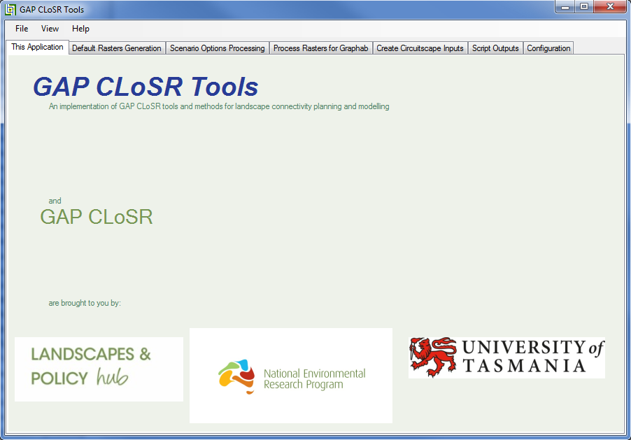

Installation
Installation files are available from http://www.nerplandscapes.edu.au/GAP_CLoSR. Currently the files are provided in a zip archive. To install the software just unzip the archive into your chosen directory. Preferably that directory should have no spaces in path. The installation file also contains example datasets and an associated scenario file.

Required Files and Folders
The two main components of GAP_CLoSR_Tools are the GAP_CLoSR_Tools.exe file and a scripts folder. By default the scripts folder is called GAP_CLoSR_Code and must be that name if it is in the GAP_CLoSR_Tools folder.
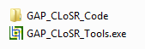
The GAP_CLoSR_Code (scripts) folder contains Python scripts and a configuration file required to run those scripts.
There may also be a file named AltScriptPath.txt in the GAP_CLoSR_Tools folder. This file is not essential at the time of first use and will be created when the application is first run. This file is a text file which just contains the path to the scripts directory.
There may be a Scenarios folder in the GAP_CLoSR_Tools folder. This folder is created when the application is run if it does not already exist. The purpose of this folder is act as a default location to store scenario settings files. Scenario settings files can alternatively be stored elsewhere on the computer.

Starting GAP CLoSR Tools
Start GAP CLoSR Tools by double-clicking the GAP_CLoSR_Tools.exe. The application will appear as a tabbed form.

Configuring Python
Open the Configuration Tab and ensure that the file path to Python (python.exe) is correct. A simple way of doing this is searching for “python.exe” in windows explorer. Then copy that file path + python.exe and paste it into the GUI. Once the python has been located click on save config.
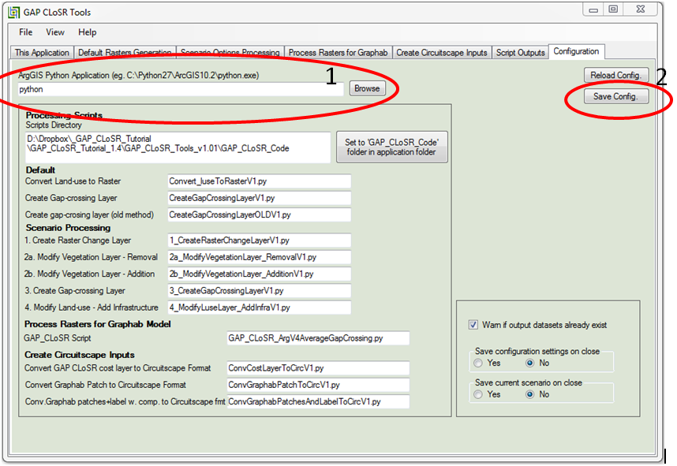

How to use the example datasets
From the 'File' menu select 'Load Scenario'. Browse to and select the scenario 'TestScenario.txt' text file in the 'Scenarios' folder. The scenario will load and most of the data-entry text boxes will be populated with text. At this stage the text in many of the text boxes will probably appear coloured red. Text will appear red if the dataset does not exist or the path is not correct. On the 'Default Rasters Generation' tab click on the browse button next to the 'Raster input and output folder (Root folder)'. Browse to and select the 'Inputs_DefaultAndScenario' folder. Most of the text in the text boxes on the 'Default Raster Generation', 'Scenario Options Processing' and 'Process Rasters for Graphab' tabs should then change to black.
Select the remaining datasets as follows:
On the 'Default Raster Generation' tab click on the browse button next to Input land-use shapefile and select 'luse.shp'.
On the 'Scenario Options Processing' tab click on the browse button next to Input change layershapfile and select 'ChangeLayer.shp'.
On the 'Process Rasters for Graphab' tab click on the browse button next to Reclass text file and select 'luse_reclass.txt'.
On the 'Process Rasters for Graphab' tab click on the browse button next to Output folder (Graphab) and select 'Outputs_forGraphab' folder.
Next go to the 'Create Circuitscape Inputs' tab and select the 'Output folder (Circuitscape)' by clicking on the associated browse button and selecting the 'Outputs_forCircuitscape' folder. Output raster names should turn black. Remaining datasets on the 'Create Circuitscape Inputs' tab can be browsed to in either the 'Inputs_Circuitscape' or 'Outputs_forCircuitscape' folders.
When text in all text boxes has turned black save the new settings by selecting 'Save Scenario' on the 'File' menu and creating a new settings file, preferably in the 'Scenarios' folder.

Things to remember:
- Files with .shp .txt or .asc extension need the full path specified
- Raster names must not have a path
- Output rasters are of ESRI GRID format unless otherwise specified
- Folders do not end in a slash character (\)
- If the text colour is red then the dataset or path does not exist
- If the text colour is black then the dataset already exists
- If the text colour is violet for a raster dataset then the name is not valid for ESRI GRID format.

When a tool is run any existing output datasets will be overwritten. To create new datasets use a different path or file names. For new output datasets the file name will appear red in the text box but will change to black after the tool has successfully run.

Normal Use of the Toolset
In using GAP CLoSR Tools please refer to the GAP CLoSR documentation (http://www.nerplandscapes.edu.au/GAP_CLoSR) which can be accessed from the internet by clicking the green 'GAP CLoSR' on the front tab if you have internet access. There is also a tutorial document which will be accessible soon.

Normally a user of GAP CLoSR Tools will start at the 'Default Rasters Generation' tab and work through the tools by working down each tab and through the tabs going left to right. The 'Default Rasters Generation' tab is used to create default datasets. Additional scenario datasets can be generated using the tools on the 'Scenario Options Processing' tab. Inputs for Graphab are generated using tools on the 'Process Rasters for Graphab' tab using selected inputs generated on the first two tabs. Tools on the 'Create Circuitscape Inputs' tab are used to generate inputs from Circuitscape.

Running Tools
There are two ways to run the tools, either individually or as a group. To run an individual tool, click the 'Run' button near the tool name. If any of the inputs are missing a dialogue box will appear listing the missing inputs and the run will be cancelled. Select any missing inputs using the text boxes or browse buttons and try again. While a tool is running the 'Run' button will be greyed out. There may be a pause while processing occurs. The 'Run' button will be enabled again when the tool has run. Afterwards, if you click on the 'Script Outputs' tab, a listing of tool run details will appear on the 'Script Text Output' window. Any errors will appear in the ‘Script Error Output' window.

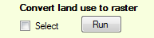

An alternative way to run the tools is to run them in groups. Tools on the 'Default Raster Generation' and 'Scenario Options Processing' tabs can be run together. Select tools to be run by clicking the 'Select' button next to the 'Run' button. When selected the 'Run' button will appear greyed out. On the 'Script Outputs' tab the 'Generate selected Default and Scenario input rasters' button will be enabled and will show the number of selected tools remaining to run. All selected tools can be run by clicking this button. They will run in the sequence in which they appear on the tabs and the number shown will count down showing the number of tools remaining to run. If an output dataset already exists a warning message will appear, asking if you would like to overwrite it. This warning message can be disabled using a check box on the 'Configuration' tab. After all scripts have run, output details can be reviewed on the 'Script Text Output' window and any errors will appear in the 'Script Error Output' window.

There is only one tool on the 'Process rasters for Graphab' tab. It can be run from that tab or by selecting it and running it using the 'Process rasters for Graphab model' button on the 'Script Outputs' tab.

Tools on the 'Create Circuitscape Inputs' tab can also be run individually or together as a group in the same ways as previous tabs. When running them as a group, use the 'Create Circuitscape inputs' button on the 'Script Outputs' tab.

Script Errors
Where there is an error in tool execution that has caused the tool to fail then an error message will appear in the 'Script Error Output' window. The causes of any errors are varied. Commonly encountered errors and solutions will be documented in the GAP CLoSR Tools Manual which is being prepared and should be available soon. Users who are familiar with geoprocessing using ArcGIS 10 and with Python scripting of geoprocessing may be able to trace the cause of any error. Otherwise users may wish to contact the developer of Gap CLoSR Tools.

Computing Requirements
GAP CLoSR Tools has been tested on Windows 7 and 8. The application also needs .NET framework version 3.5 (or higher) installed on the computer and ArcGIS 10 (or higher). The tools can be adapted to run with ArcGIS 9.2 and 9.3.
Addition technical specifications will appear in the GAP CLoSR Tools Manual.

Configuration Notes
Configuration settings are found on the last tab of the GAP CLoSR Tools application. This includes the ArcGIS Python application and details of the script folder and files. These files are loaded at application start-up and all text boxes on this tab should contain text which should be black. If any of the text boxes are blank or have red text then that indicates a problem with the settings file. The default scripts directory is the same folder as the GAP_CLoSR_Tools.exe file. The ArcGIS Python Application will depend on what version of ArcGIS 10 you have and can be (for example) 'C:\Python27\ArcGIS10.1\python.exe' or 'C:\Python27\ArcGIS10.2\python.exe' or alternatively just 'python' will work in most cases. If the text turns to black then it should be correct. Further configuration details will appear in will appear in the GAP CLoSR Tools Manual.

